

CSE-326 Sec:K19PB

Group:G-19

Project: TRAVELING BLOG

**CONTENTS:**

* ABSTRACT OF PROJECT.
* INTRODUCTION.
* WEBSITE DESIGNUNG.
* CONCLUSION.

|  |  |  |  |  |
| --- | --- | --- | --- | --- |
| Roll | Roll NO. | Registration number | Group Member | S.NO. |
| **He did the half of this final report and he Design**  **The another report.** | **55** | **11919139** | **Arif Abdullah Ripon** | 1 |
| **Design latest information for project and all the links.**  **The fires report and half of final report.** | **56** | **11919489** | **Emad Khaled Mohammed ahmed alsabri** | 2 |
| **He makes the code and the video.** | **57** | **11910233** | **Donthula Akshay** | 3 |

**ABSTRACT OF PROJECT**

**Travelling blog is a website in which you can find different places for visiting. It makes travelling easy by showing different amazing places and also it shows flight timings for different places and price of flight . So anyone who wants to travel can just scroll internet and compare the best way to go and book your flight. In travelling blog you can even book your flight and decide the day of arrival and day of return.**

**Introduction**

**Travelling blog is a website which show you different interesting places to visit and it also show you the flight timings and you can book your flight in the website. It makes travelling easy by comparing different flight timings.** **It makes travelling easy by comparing time of flight and cheapest flight at that time. Some travelling blog also give you free guide for visiting new places.**

**WEBSITE DESIGNING**

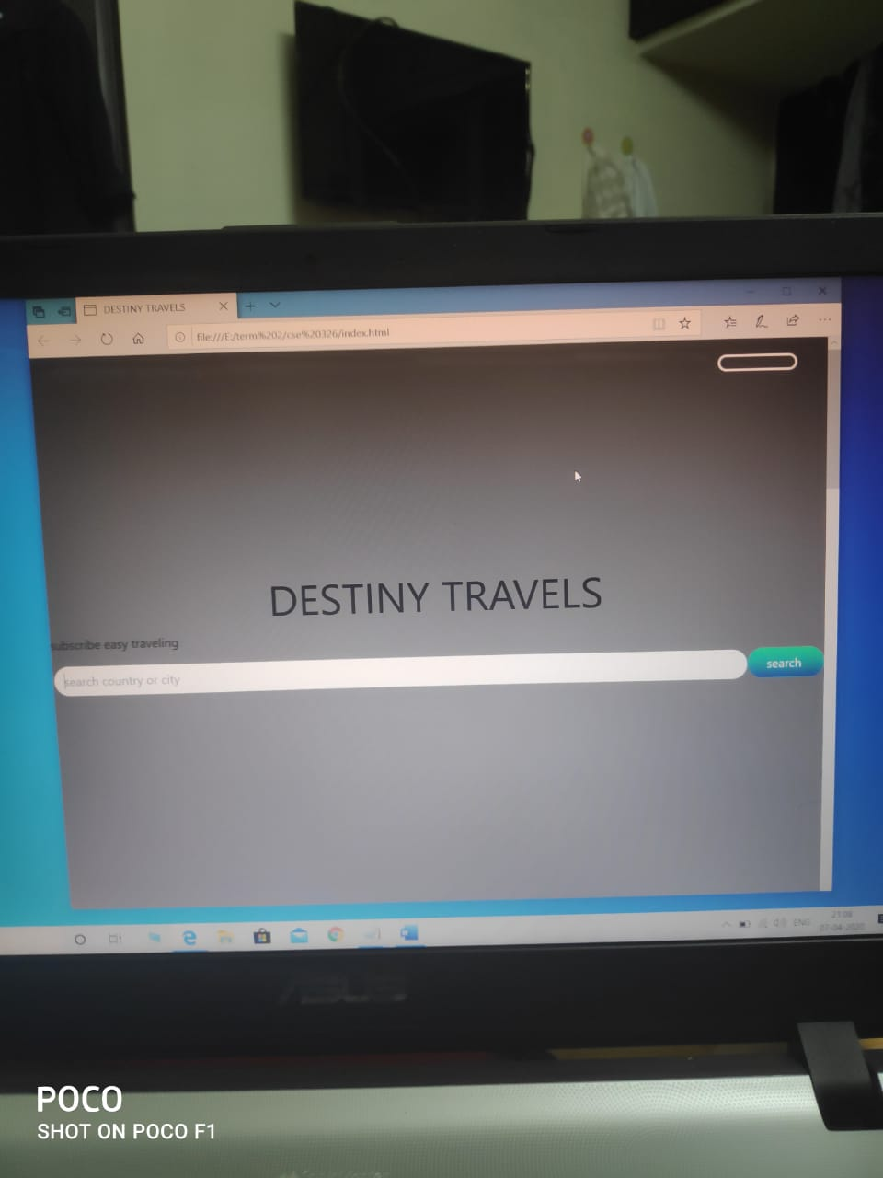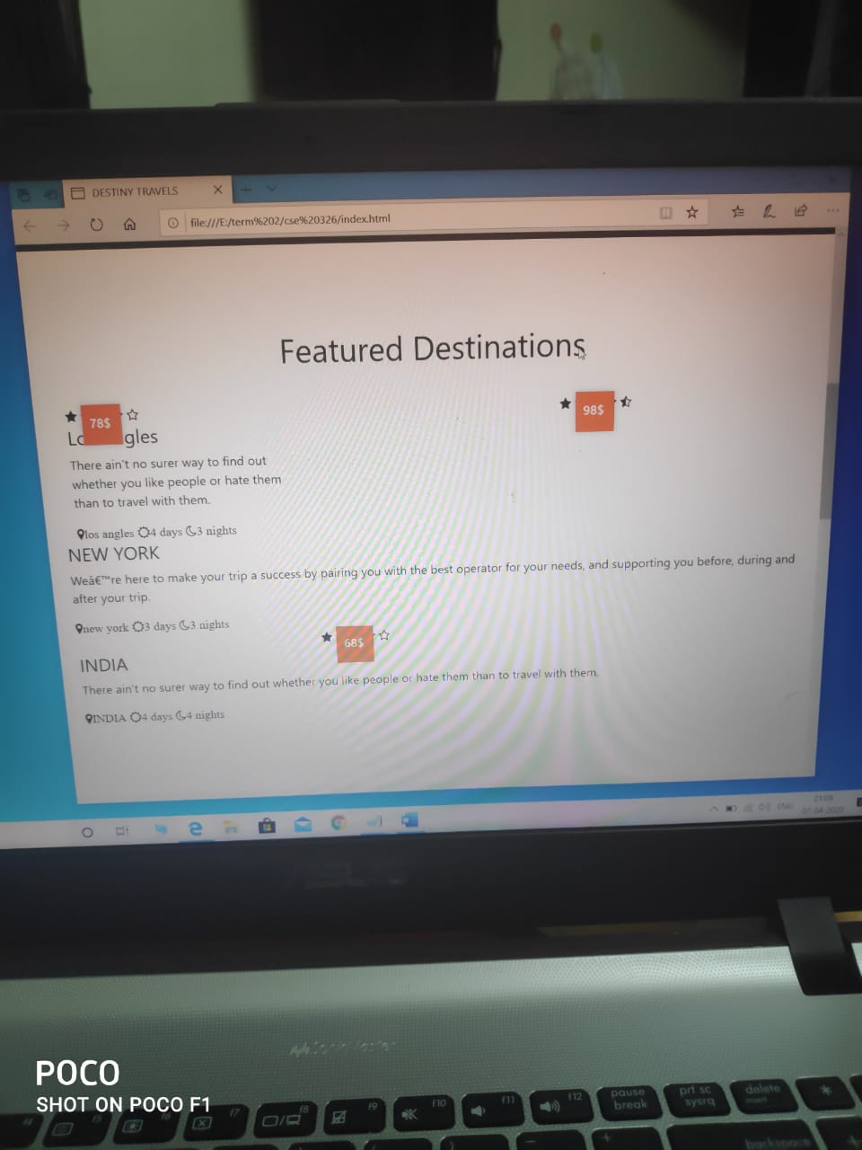

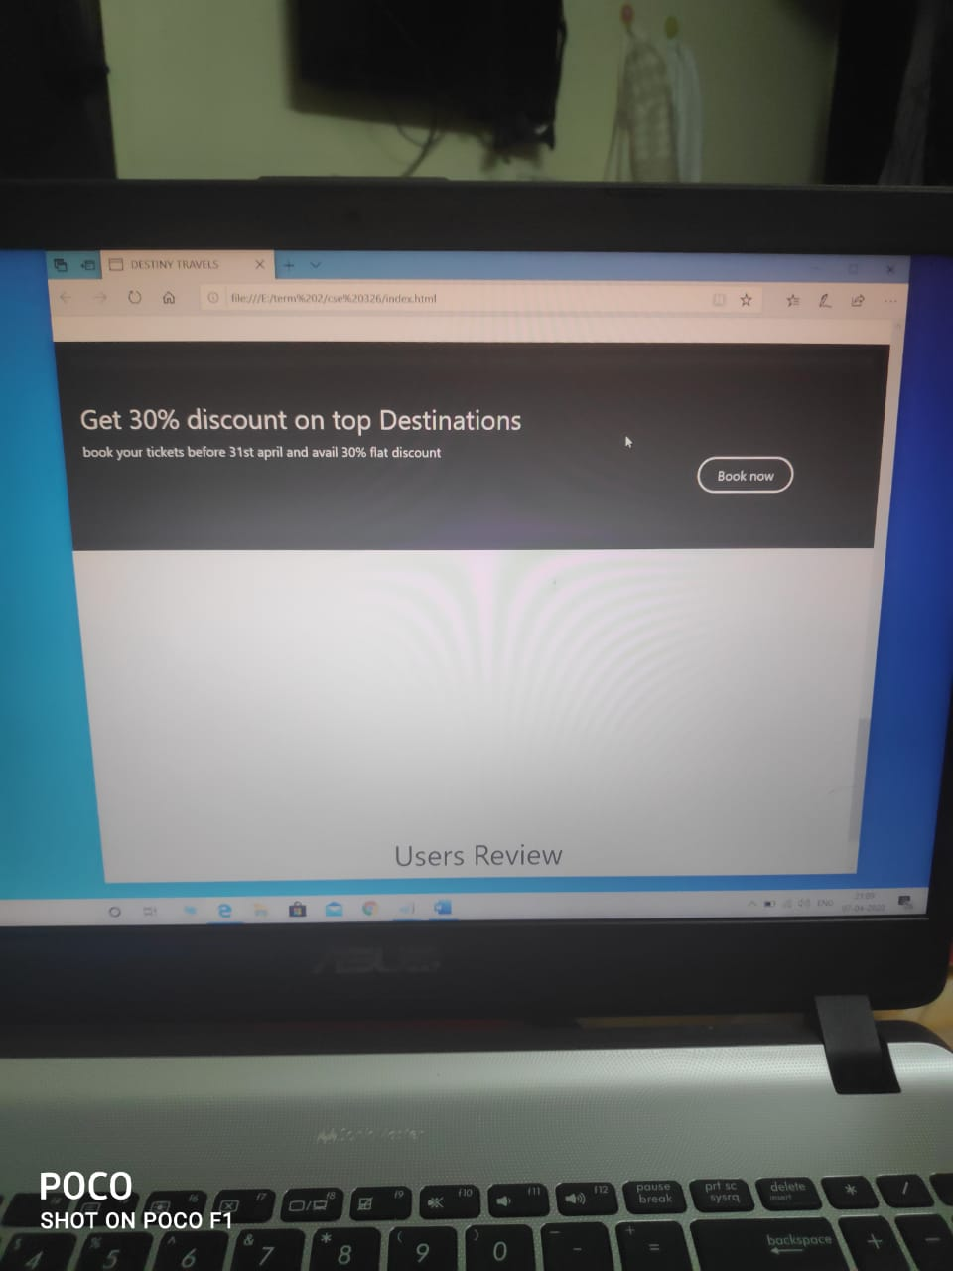

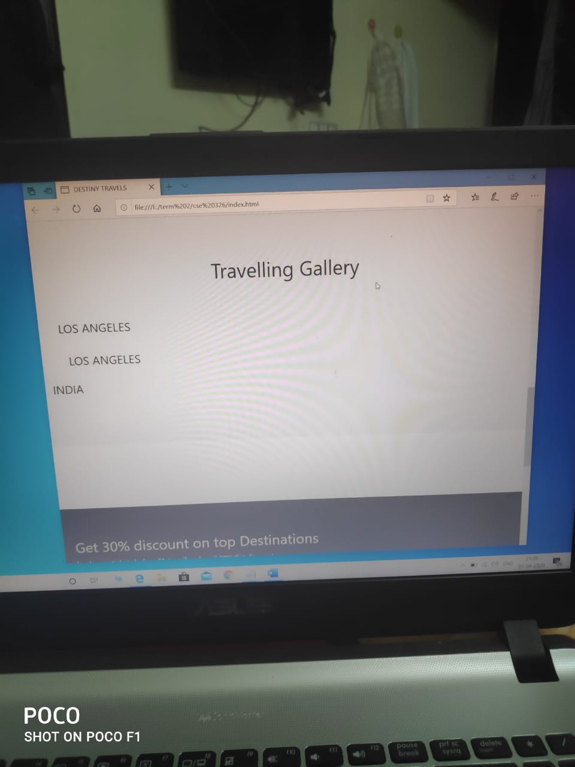



**HTML**

It is a markup language used in creating and designing pages and websites. This language is one of the oldest and most widely used languages ​​in designing web pages. HTML The structure of a web page and gives the web browser a description of how it displays its contents, techniques such as Cascading Style Sheets (CSS) and scripting languages ​​such as JavaScript can help web browsers receive HTML documents from the web server or from the file system and display them, and the HTML language function is a description of the structure of pages The web structurally.

HTML elements are the basic building block of HTML documents, as we can add images and interactive objects such as forms or video and audio files. You can also create structured documents by using tags to declare paragraphs, titles, links, quotes, tables, and more.

HTML can include programs written in languages ​​like JavaScript toodify the behavior and content of webpages; CSS cascading style sheets codes that define the look and layout of the content.

|  |  |  |
| --- | --- | --- |
| For what we use | Tags | NO. |
| Knows the document type | <!DOCTUPY> | 1 |
| document is HTML markup language | <html> | 2 |
| Header section of an HTML document | <head> | 3 |
| The main body (body text) of an HTML document | <body> | 4 |
| Sets the push / hold button | <button> | 5 |
| Defines a Heading different level sizes | <h> | 6 |
| Used to insert an image into a web document | <img> | 7 |
| A general container for text blocks | <div> | 8 |
| use to create a link to another page | <href> | 9 |
| The tag specifies a paragraph | <p> | 10 |
| tag specifies an input field where the user can enter data | <input> | 11 |
| It can be used to refer to an artistic term | <I> | 12 |
| Used to group elements contained in the document | <span> | 13 |
| Used to shrink text | <small> | 14 |

**CSS**

CSS is a shortcut to (Cascading Style Sheet) a descriptive language that gives the website its beautiful appearance and unique design that will distinguish it from other sites. The CSS language is friendly to the HTML language, as it always accompanies it and its side in designing and creating web pages. Both of these languages ​​form the basis of every website. HTML is the basis of all elements of a webpage. As for CSS, it is the basis of website design and layout. Without it, websites will remain plain text on white backgrounds.

Before the CSS language was built and developed in 1996 by the World Wide Web Consortium (W3C), the web pages were limited and very simple in form and function. The old browsers were displaying web pages as pages consisting of black text with a white background only (text - images - links..etc) without any design mentioned. There was no planning for when to launch the CSS language.

CSS has allowed the design and creation of web pages in many different ways to be able to understand the person's creativity, such as the ability to

Define lines, margins and distances for site elements.

Determine the color and size of the elements. Apply colors to backgrounds. Move the items freely and get many movements on the site And many other advantages.

|  |  |  |
| --- | --- | --- |
| For what we use | Tags | NO. |
| defines the innermost portion of the box model | Padding | 1 |
| Sets the margin on all four sides of the element. | Margin | 2 |
| Specify the height of an element. | Height | 3 |
| allows you to control the BG of any element | Background | 4 |
| Sets the horizontal alignment of inline content. | Text- align | 5 |
| data type represents a color in the color space | Color | 6 |
| page or a section | Header | 7 |
| specifies the width of the element's content area | Width | 8 |
| allowing text and inline elements to wrap around it | Float | 9 |
| allows you to rotate, scale, move, skew…. | Transform | 10 |
| sets whether an element is treated as a block or inline | Display | 11 |
| allow you to specify the style, width, and color of an element's border | Border | 12 |
| is meant for setting the weight (boldness) of the font | Font-weight | 13 |
| Defines the font size for the text. | Font-size | 14 |
| property adds shadow effects around an element's frame | Box-shadow | 15 |
| sets how an element is positioned in a document | Position | 16 |
| Specify the location of the left edge of the positioned element. | Left | 17 |
| affects the horizontal position of a positioned element | Right | 18 |
| allows you to specify the type of cursor that should be displayed to the user. ... By default | Cursor | 19 |
| property specifies the name of the | Transition | 20 |
| effects the vertical position of a positioned element | Top | 21 |

**CONCLUSION**

**Advantages:**

1:-Travelling blog make easier way to compare between different flights.

2:-It uses less time than going to book yourself for traveling, you can directly scroll and it will do the booking for you.

3:-By travelling blog you can decide arrival day and returning day by your own wish.

4:-Some travelling blog give you free guide for visiting any city.

5:-You can decide which city is best for your different types of vacation or visit.

6:-They can reduce your expenses as they give cheap flight tickets to customers by best deals.

7:- you can have a good business by make deal and commission from airlines.

**Disadvantages:**

1:-You have to be careful during payment there are fake sites also on internet.

2:-Some travel blog are not so secured they are easy to hack that is biggest problem.

3:- Sometimes customer can get fake website and all their data is hacked.

**Finally**

Hacking is a big threat to your travelling blog as, some hackers are there who can hack your website and make wrong use if it so you should pay attention to cyber security.



***Thanks LPU***